20.56: See Figure (20.15(c)), and Example 20.8.
a) For the isobaric expansion followed by the isochoric process, follow a path from
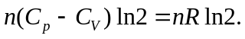
b) For the isochoric cooling followed by the isobaric expansion, follow a path from

